IMPLEMENTATION PLAN OF AGRICULTURAL EXTENSION EDUCATION & COMMUNICATION DEPARTMENT FOR
B.Sc (Hons) Degree Program

AT Findings | Corrective Action | Implementation Date | Responsible Body | Resources Needed
Need more Practical Work. | More practical knowledge is required to be induced to the students through field days and modern technology and innovations. | June 2013 | Chairman of the Department | Finance
Need of Social work and Tutorial groups. | Social work and Tutorial groups are to be introduced again in the university as it was a good practice in earlier days. | June 2013 | Chairman of the Department | Nil
Need of practical assignments during summer vacations. | The students may be attached to the farm families in shape of groups during their summer vacations, to learn practically knowledge about agriculture. | June 2013 | Chairman of the Department | Nil
The equipments available in studio are old and obsolete. | These equipments may be replaced by modern Audio Visual equipments. As it is the age of IT. | June 2013 | Chairman of the Department | Finance
No multimedia projector facility is available for class lectures and communication lab. | Purchase of multimedia projector for classrooms and communication lab. | December 2012 | Chairman/Purchase Committee | 04 Multimedia projectors.
No electricity back up is available in class rooms and communication lab. | Purchase of generator or UPS to provide electricity in the lecture rooms, offices and laboratories. | As soon as possible | Chairman/ Store Officer | Generator or UPS
The department has no computer laboratory for B.Sc (Hons) students. | Project proposal may be submitted to the HEC for establishment of computer laboratory. | 2012-2013 | Chairman/ORICs/P&D | Computers, printer, scanner and other related equipments.
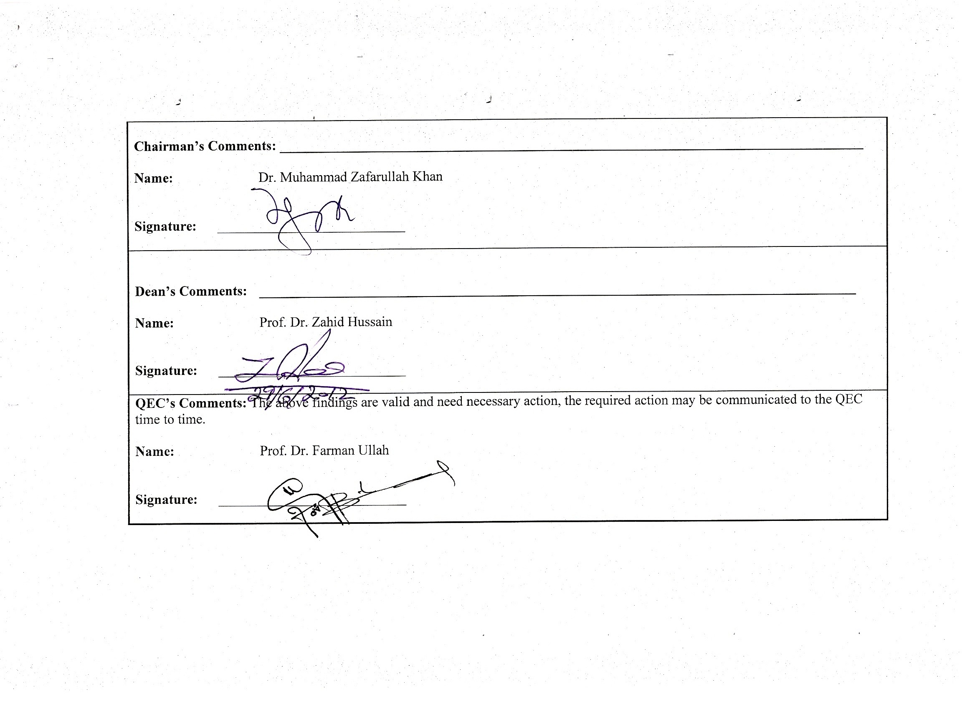

Chairman’s Comments: ____________________________________________________________________________________

Name: Dr. Muhammad Zafarullah Khan

Signature: ___________________________

Dean’s Comments: ______________________________________________________________________________________

Name: Prof. Dr. Zahid Hussain

Signature: ___________________________

QEC’s Comments: The above findings are valid and need necessary action, the required action may be communicated to the QEC time to time.

Name: Prof. Dr. Farman Ullah

Signature: ___________________________

